Exercise #1
- Write the complete SQL statement for creating a new database called addressbook.
CREATE DATABASE addressbook;
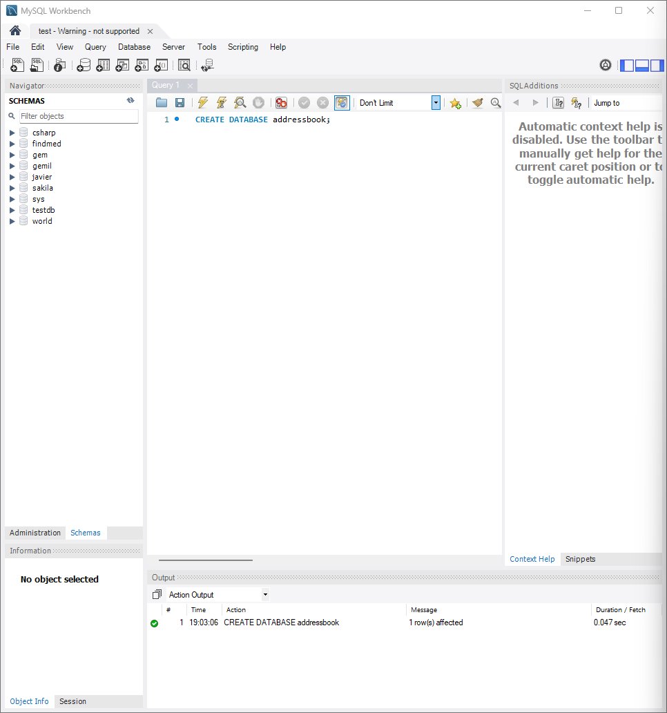

- Which statement is used to list the information about a table? How do you use this statement?

-- Use a pre-existing database
USE findmed;
DESCRIBE users;
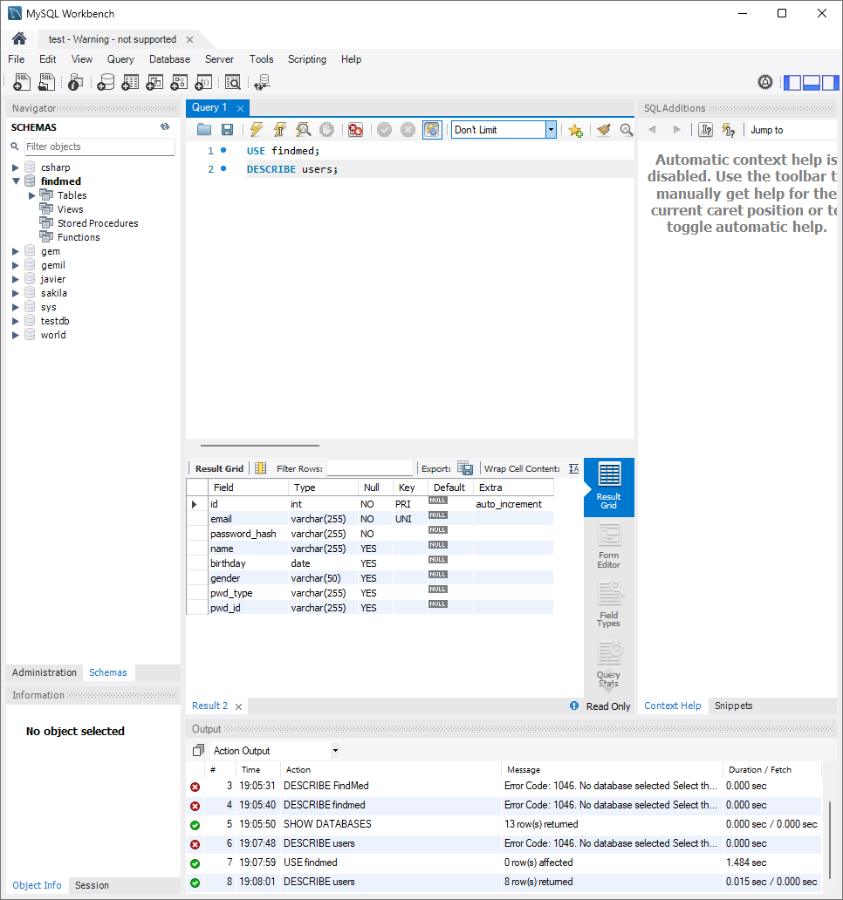

- How would you list all the databases available on the system?
SHOW DATABASES;
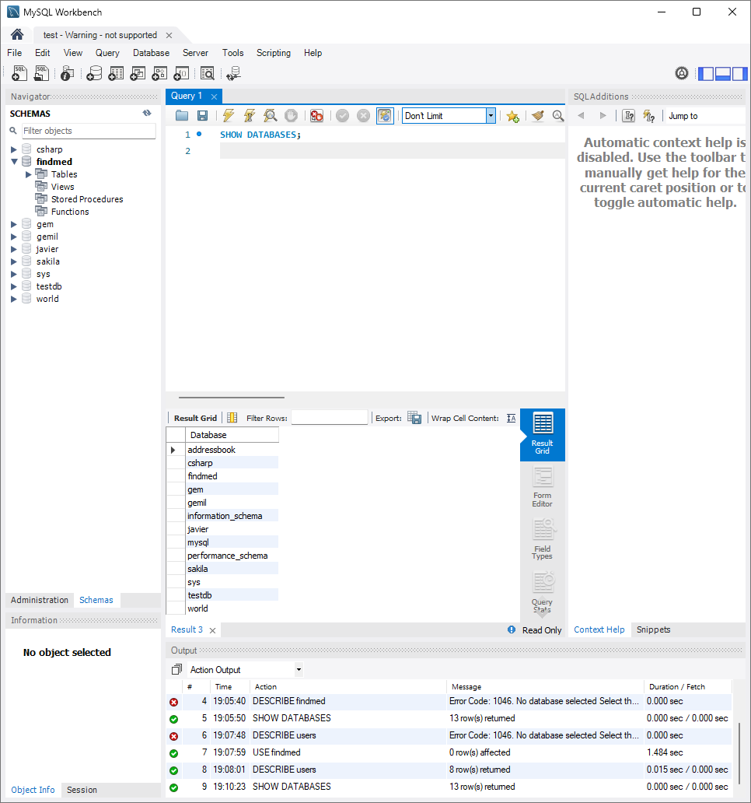

- Write the statement for inserting the following data in employee data table
-- Create table first
USE addressbook;
create table employee
(
id int PRIMARY KEY AUTO_INCREMENT,
f_name varchar(50) NOT NULL,
l_name varchar(50) NOT NULL,
title varchar(100),
age int,
yos int,
salary double,
perks double,
email varchar(100)
);
insert into employee_data values(null,"Rudolf","Reindeer","Business Analyst","34","2","95000","17000","rudolf@bugnet.com")
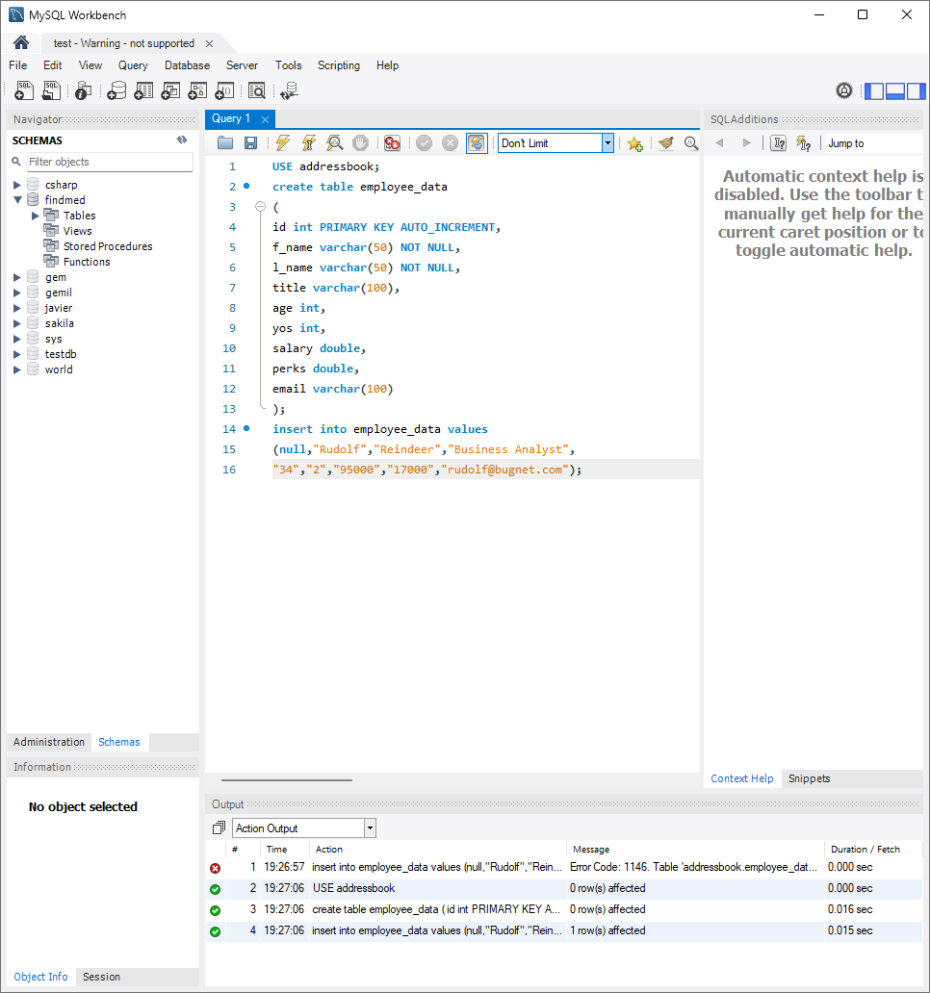

- Give two forms of the select statement that will list all the data in employee_data table.
SELECT * from employee_data;

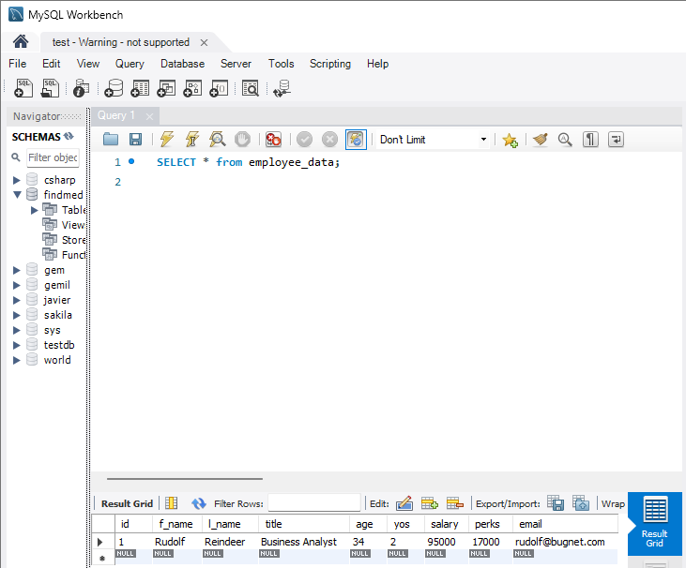
SELECT f_name, l_name, title, age, yos, salary, perks, email from employee_data;

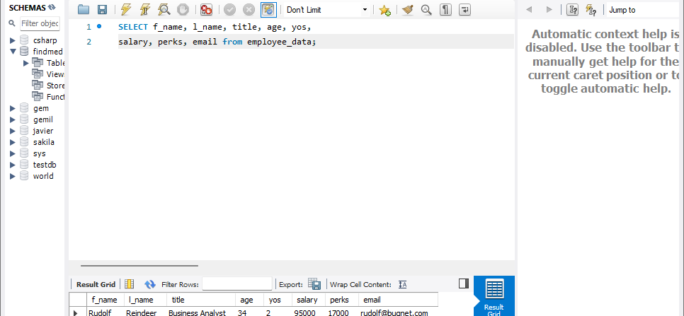
- What will select f_name, email from employee_data; display?
Will return all data from table but only display the first name and email
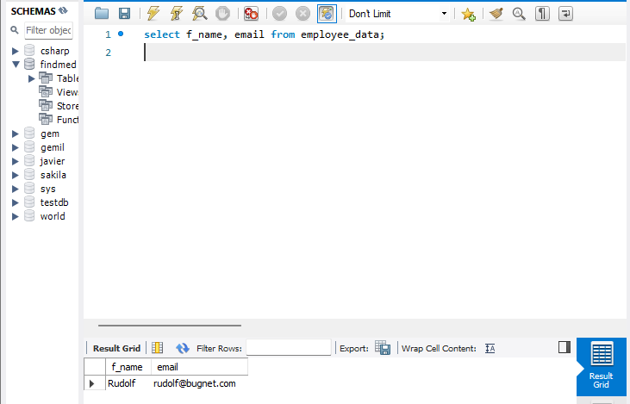

- Write the stamen for listing data from salary, perks,and yos, columns of employee-data table.
SELECT salary, perks, yos from employee_data;

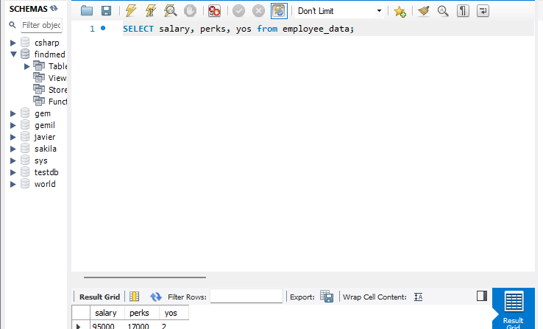

- How can you find the number of rows in a table using the select statement?

select count(id) as number_of_rows from employee_data;

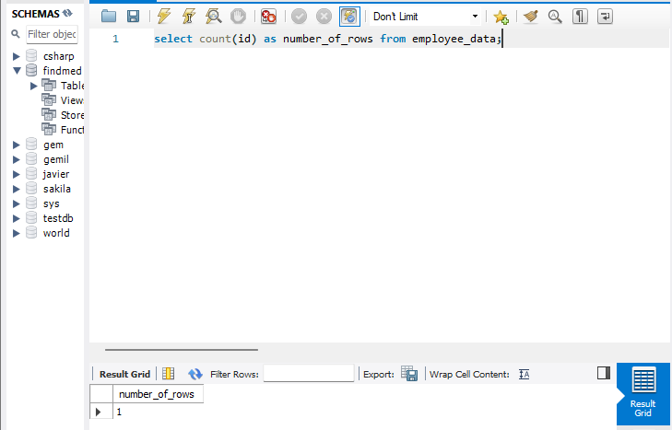

- What will select salary, l_name from employee_data; display?

